

|  |  |
| --- | --- |
| Product Fields | Details |
| Product Name | apple watch |
| Number of Comments Checked | 14518 |
| Overall Product Sentiment | Positive |
| Components Analysed | ['display', 'digital crown', 'side button', 'heart rate sensor', 'accelerometer', 'gyroscope', 'ambient light sensor', 'speaker', 'microphone', 'battery'] |
| Prompts Used | ["{questionstring} . \n With the above text, generate me a recommendation for how to improve a {product} . If you can't answer it, reply with 'No Recommendation Given'", 'Give me the properties of a {product} {components} in a python dictionary. Do not print anything other than the python dictionary', 'Retrieve the generic parts of a {product} in a python list. Do not print anything other than the python list.'] |
| Model Accuracy | {'Classification Accuracy': 0.41, 'Sentiment Accuracy': 0.93} |
| Date Generated | 2023-04-16 |

## Sentiment Graph Over Time

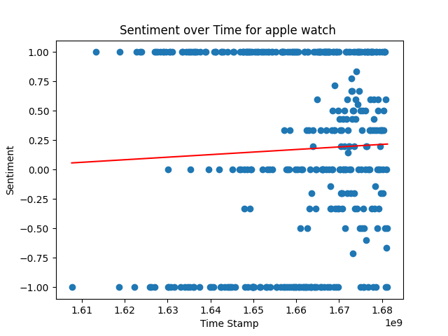

## Table of Recommendations

|  |  |  |  |
| --- | --- | --- | --- |
| Component Specification | Recommendation | Priority | Current Benchmark |
| display screen_size_inches | No Recommendation Given. | 4.0 | 1.57 |
| digital crown material | No Recommendation Given. | 1.0 | stainless steel |
| digital crown design | Recommendation: Increase the size of the speaker and make the action button more tactile for easier use. | 0.0 | ergonomic and intuitive |
| side button functionality | Recommendation: Consider enhancing the airdrop/na feature on the Apple Watch to make it more user-friendly and efficient for sharing files and data. This could include improving the syncing speed and expanding the types of files that can be shared. Additionally, incorporating a notification system for successful transfers could be a useful addition for users. | 2.0 | multifunctional |
| heart rate sensor Type | Recommendation: Integrate a heart rate monitor into the Apple Watch. | 1.0 | Optical sensor |
| accelerometer power consumption | Recommendation: Apple could consider implementing a feature that utilizes the built-in accelerometer to capture and convert kinetic energy into electrical energy to recharge the battery. This would improve the battery life of the watch and increase its functionality. | 1.0 | low |
| accelerometer technology | No Recommendation Given. | 1.0 | 3-axis accelerometer |
| ambient light sensor type | No Recommendation Given. | 1.0 | photodiode |
| speaker Brand | Add haptic feedback to the watch's button press to compensate for the lack of travel and improve user experience. | 0.0 | Apple |
| speaker Type | Recommendation: Apple could consider further improvements to the watch's call quality, such as more advanced noise-cancelling technology, to make taking calls on the watch easier and more pleasant for users. Additionally, they could explore ways to make language learning on the watch more accessible and engaging, perhaps by adding more interactive features or partnering with language learning services. | 1.0 | Speaker |
| speaker Connectivity | Recommendation: Apple could consider integrating Speaket technology into the Apple Watch to enhance its capabilities for taking calls and viewing videos. With its compact size, Speaket technology could be easily integrated into the watch and offer an improved user experience. | 1.0 | Bluetooth |
| speaker Sound Quality | A recommendation to improve the Apple Watch could be to improve the sound quality by adding a built-in speaker and featuring Dolby Atmos speakers with a right-left audio switch. Additionally, including an extra button for easy access to music and louder volume controls would enhance the user experience. Another improvement could be adding a larger battery for longer wear time, and including a mini Bluetooth to connect to other devices seamlessly. | 5.0 | Decent |
| speaker Size | Recommendation: Improve the touch sensitivity of the Apple Watch screen to prevent accidental button presses and improve accuracy when typing or dialing. Additionally, consider improving battery life to avoid the need for frequent charging. | 0.0 | Small |
| microphone type | Recommendation: Add a display/nextra button speaker/n feature to the Apple Watch, allowing for easier navigation and clearer communication during phone calls or voice commands. | 0.0 | digital |
| microphone sensitivity | No Recommendation Given. | 1.0 | good |
| microphone frequency response | Add an extra microphone and speaker to the Apple Watch for improved communication during phone calls and Siri interactions. | 1.0 | 20Hz-20kHz |
| battery Compatibility | Recommendation: Improve the battery life of the Apple Watch to last for at least a week of normal activity and up to 36 hours on extended mode. Additionally, consider making it compatible with regular magsafe and improving the design to be more durable and waterproof. These improvements will make the Apple Watch more suitable for international travelers and for those who need to track sleep, without compromising the industrial design. | 5.0 | Apple Watch Series 1 - 6 |

Thanks for using the product to generate a report for the apple watch. We hope that the 20 recommendations   
 you have gotten was beneficial for your product developement journey! In general the product has received Positive  
 ratings from the youtube and amazon community which are our main source of feedback.